**By**

**Group 5 (Thursday Class)**

**Submitted to**

**The University of Roehampton**

**Software Engineering Group Report**

**Project Report Title:**

**Crud Application (On Population Information)**

**CMP020N204S**

## **Declaration**

We hereby certify that this report constitutes our own work, that where the language of others is used, quotation marks so indicate, and that appropriate credit is given where We have used the language, ideas, expressions, or writings of others.

We declare that this report describes the original work that has not been presented before for the award of any other degree of any other institution.

**Group members Name:**

Muhammad Umar Imtiaz

Malik Abaid Ur Rehman

Arsalan Ahmed Baig

Date: 25 April 2023

# **Table of Contents**

1. Introduction vii

Research Question or Problem that will be Addressed vii

Aims vii

Objectives vii

Legal, Social, Ethical and Professional Considerations vii

Background vii

Report overview vii

1. Literature or Technology Review viii
2. Design or Methodology ix
3. Implementation or Results x

Evaluation x

1. Conclusion xi

Reflection xi

Future Work xi

## **Introduction**

### This project consists of for building web-based CRUD application that is useful for easy access to the population information. It has user-friendly interface. The project has built using the PUG as for front-end, Node.js is used for back end, and Express.js is used for the communication between the front-end and back-end. The project follows the Agile and Kanban techniques. This project has MySQL database for storing and retrieving the population information data. This project has version-controlled using the Git and publicly accessible on GitHub. This project has ability to provide a solution that allows our users to generate various reports on population information data. This population information is consisting of countries, cities, capital, and their region-wise data. This project has ability to add new data in database and applying the various security options for user authentication. This security authentication has feature to secure our user credentials.

### **Problem that will be Addressed** **(Hypothesizes):**

### While developing this crud application. We had Some Concerns related to our built application. So, hypothesizes regarding this project are given below:

### **Hypothesis 1:** By prioritizing the requirements for project and divided tasks between our team members, we must ensure that our application should complete within the given period.

### **Answer:** Allocating the work between scrum group and requirements prioritizing are most crucial factors for project management because which are used to ensure that project keeps on track. It is also important that everyone should complete his work before the deadline. If someone faced any problem, while application’s development. He should discuss it in group meeting because it could cause for delay.

### **Hypothesis 2:** By generating reports through organize population data by country, capitals, and regions, we can be able to provide the awareness to the organization according to global trends.

### **Answer:** This application consists of useful information about population data as real-world trends Because the Organization can access accurate and quality of data from it.

### **Hypothesis 3:** By applying security features and login credentials, we can be able to check that our application is secure and accessible only to authorized users.

### **Answer:** The security measures and login features are especially important components for online application because through that unauthorized user can’t be able to access organization’s resources or data.Top of Form

### **Aims:**

### This project has different Aims and Objectives that are following below:

### This project must develop a CRUD application using PUG, Node.js, and Express.js programming languages.

### To create a MySQL database for storing and used a Git for version control.

### To be deployed the application as a Docker container.

### To apply Scrum, Agile and Kanban techniques for the management of project.

### And this project is to gain experience through tools with our Scrum teams.

### **Objectives:**

### The objectives are given below:

### This project is to identify the scope and requirements of the project,

### To priorities the requirement and to allocate the tasks with our team.

### To help with identifying the stakeholders and to manage the risks.

### To generate the reports on population information from the given SQL database.

### To provide additional functionality such as adding new data to the database and applying security measures.

### To create specific reports and information for countries, cities, and various capital cities.

### This project is to calculate and display the number of people who speak specific languages like English, Chinese and Hindi etc., and their percentage of the world population.

### **Legal, Social, Ethical and Professional Considerations:**

**Legal considerations:**

There are many legal considerations that are related to our project such as data protection laws, copyright laws, and intellectual property laws. We must ensure according to these laws that we should not violate data or application if someone owns application else.

**Social considerations:**

The project deals with sensitive information related to population statistics, that is why it is essential to be sensitive to cultural and social issues. These all things are related to the data. Additionally, we are trying to consider how the application might affect separate groups of people, such as those in developing countries or local communities.

**Ethical considerations:**

The ethical consideration of this project consists of data privacy, data security, and responsible data usage. We have ensured that the data is collected, stored, and processed in an effective way that will protect the privacy of individuals and protect the data from unauthorized access.

**Professional considerations:**

The professional consideration of this project consists of professional standards of conduct, following industry’s best practices, and ensuring that the work is based on high quality. We have ensured that the work is completed on time and meets the exact requirements.

### **Background:**

Our project has consisted of designing and implementing a new system for reporting the population information data, with the help of database. The purpose of this project is to create a CRUD application which is used as a front-end to a database, and providing a method to create, read, update, delete data from website.

We have worked as a scrum team and use unique design methods like User-Stories and Use-Cases. We also used project management methods like Agile and Kanban. We will also use the many software development tools such as Visual Studio, Git, and Docker.

## **Technology Review**

The technology review focuses on technology that has used for this project. Typically, we have reviewed different technology stack and tools for our project and summarized these options below.

**Front-End:** The front-end is used to develop by Pug. Pug is a template that is used to write clear and efficient HTML code. It consists of simple syntax as compared to regular HTML. Pug is helpful to use variables, conditional statements, and loops that makes it powerful in term of generating dynamic HTML content.

**Back-END:** The back end is used to develop by Node.js (JavaScript). The JavaScript is helpful for developers to build quality applications. A Node.js consists of non-blocked input / output models which makes it unique for creating good applications that need frequent updates.

**Express.js (Communication):** The Express.js is used as communication link between front-end and back-end. It provides many features which are used to simplify the web applications process or development. it also provides easy integration with other Node.js modules that makes it flexible and powerful tool for creating web applications.

**Database:** MySQL database is a widely used for storing and retrieving the data. it also provides scalable solution for storing and retrieving data. it is customizable and provides a wide range of data types which makes it flexible tool for handling data.

**Git**: This application is version controlled by Git and it is widely used distributed version control system. it provides straightforward way to changes in code. it is also integrating good with other tools like GitHub which makes it powerful for making software.

**Deployment:** This application is deployable as a Docker container. A Docker is a platform that provides lightweight and effortless way to deploy applications. It provides a way for developers to manage an application and its dependencies into a signal container.

**Other Tools:** In this project, we also use some other tools like Visual studio. Visual studio is an integrated development environment which provides unique features for creating web applications including code editing, debugging, and testing.

## **Design and Methodology**

* To understand the project specifications and users need as development team. We created User stories that are used to help our team to describe the application actions according to users’ perspective.
* We design use cases and use case diagram which tell us how user can interact with system. The Use cases are used to identify actions, their goals and required steps that are used to get the goals.

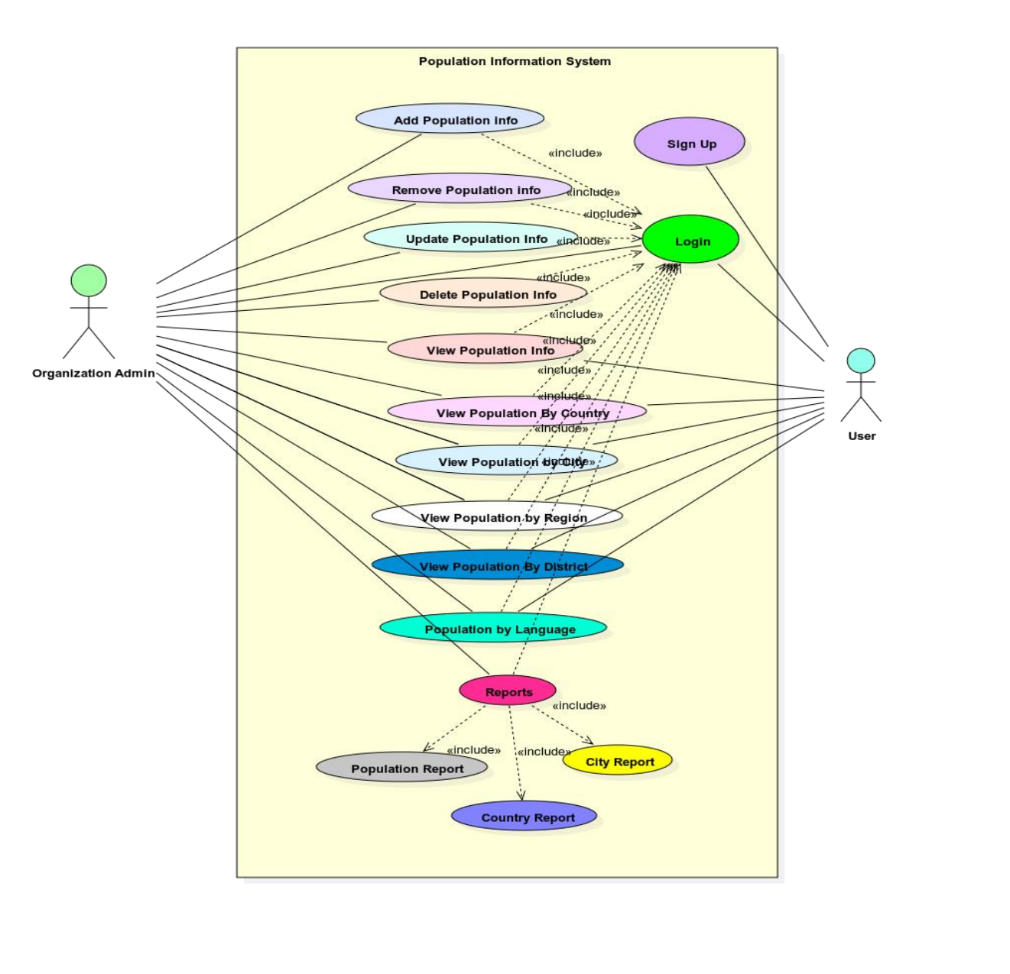

Figure-1

* We also made class diagram to get better understanding of the project implantation.

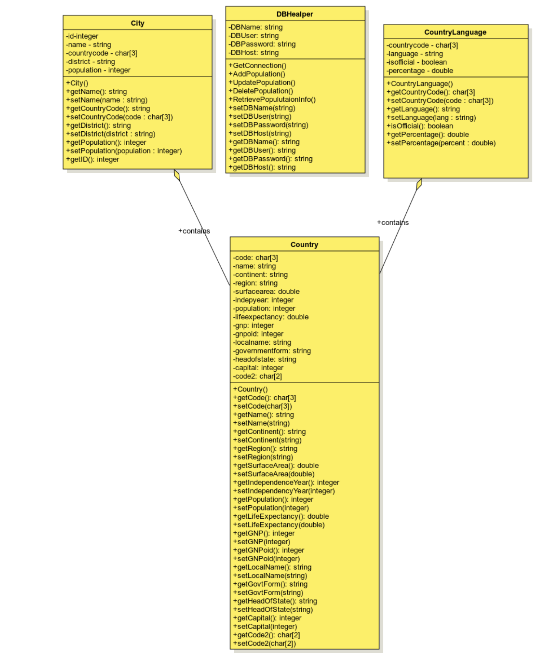

Figure-2

* We will use Agile management methodology that are used to manage the project in efficient way. It will be developed our focus on delivering working software at the end of each sprint.
* Kanban will use as a visualization tool to check the progress of project workflow.
* For developing the web application, we will use Visual studio in term of integrated Development Environment
* To check the changes made to the code and coordinate with our team members, we will use Git as a version control system.
* We will use Docker to check the application and its dependence into a container that can be deployed anywhere.
* We will also use Database system to save and retrieve data from our web application.

## **4. Results**

The result of our group project will show as developed CRUD (Create, Read, Update, Delete) web application which provided a front-end to a database for Population information. The application will allow its users to create different population report by country, capitals, cities, and regions. The application will also allow users to view the population breakdown of people living in cities and not living in cities. it will provide the number of people who speak different languages like Chinese, Arabic, Hindi, English and Spanish.

The application will consist of additional functionality like, to add new information in database and security measures like login credentials.

### **Evaluation**

### The first thing would be for us to gather all functional and non-functional requirements for this project because this would consist of to identify all reports which need to create and the various kinds of data that need to be stored and retrieved from database system.

### The next challenge for our team to design the application. This would be based on to create user stories and use cases because it would help us to check the functionality of our application.

### Once we as a scrum team finalized the design of our application then we would start the development process. So, we would need to become familiar with development tools like Git, Visual studio, and Docker.

### When development process will complete then it will be particularly important for us to test our application continuously to check that it is working properly or not. For testing, we will do unit testing, Integration testing and Circle CI.

### After the application is fully developed and tested, it would be deployed like a Docker Container.

### It would be particularly important to add security features like login and password to secure our application for unauthorized users according to Organization requirement.

### Our team would try to add some extra features to make it useful and user-friendly for Customers.

## **5.Conclusion**

According to the project requirements, we developed a CRUD (create, read, update, and delete) application for an organization that allows easy access to population information. In this project we worked as a Scrum team and adopt design techniques and project management methods like Agile, and Kanban.

The basic purpose of this application is to provide a population information to users through that users can generate reports like as population statistics for countries, capitals, regions, and cities.

**To reflect on our project, we should consider the following questions:**

**What went well during the project?**

Overall, the project went very well because every group member had a good coordination and collaboration with team. Everyone used to do their work on given time, if someone stuck on some point then every team member tried to figure out that problem.

**Were the project goals and requirements met?**

The application is working fully functional because it was developed according to organization requirements. The design techniques and project management methods were implemented correctly, and everything was tested regularly. The application was deployed as a Docker container.

**Were there any unexpected challenges? If so, how were they addressed?**

The problem we faced during this project was to build the communication channel between the front-end and back-end. So, our team members worked collectively to address this problem and learned to apply Express.js.

**What did you learn from the project?**

Overall, we did an excellent job during this project because we as a group learned many things from each other’s like team management, communication style, problem handling techniques, and risk management.

**For future work,** we tried to improve our coding skills because it will help us to enhance our skills in the field of web development. So that, we will be able to optimize additional functionality, project’s performance, and improve its scalability or add new features to enhance it.

In addition, we will try to update our project’s interface more familiar for the users and statistical researchers who are trying to generate reports on population data. Our application will help different countries’ expert to make decision for effective policies, management and planning of their economy and population.